Deliverables: smith.csv and smith.py

**Instructions to produce smith.csv with smith.py**

1. Open the file, smith.py, in a coding environment

Here is the [webpage](https://code.visualstudio.com/) to download Visual Studio if you don’t have a IDE available.

1. After applying edits to the file paths as outlined below, Hit ‘Run’, and the code will run and automatically output a csv file. The csv file will be found in the same folder that you have saved the file, smith.py, to.
   1. In Visual Studio, the ‘Run’ button is on the top left corner.
      1. 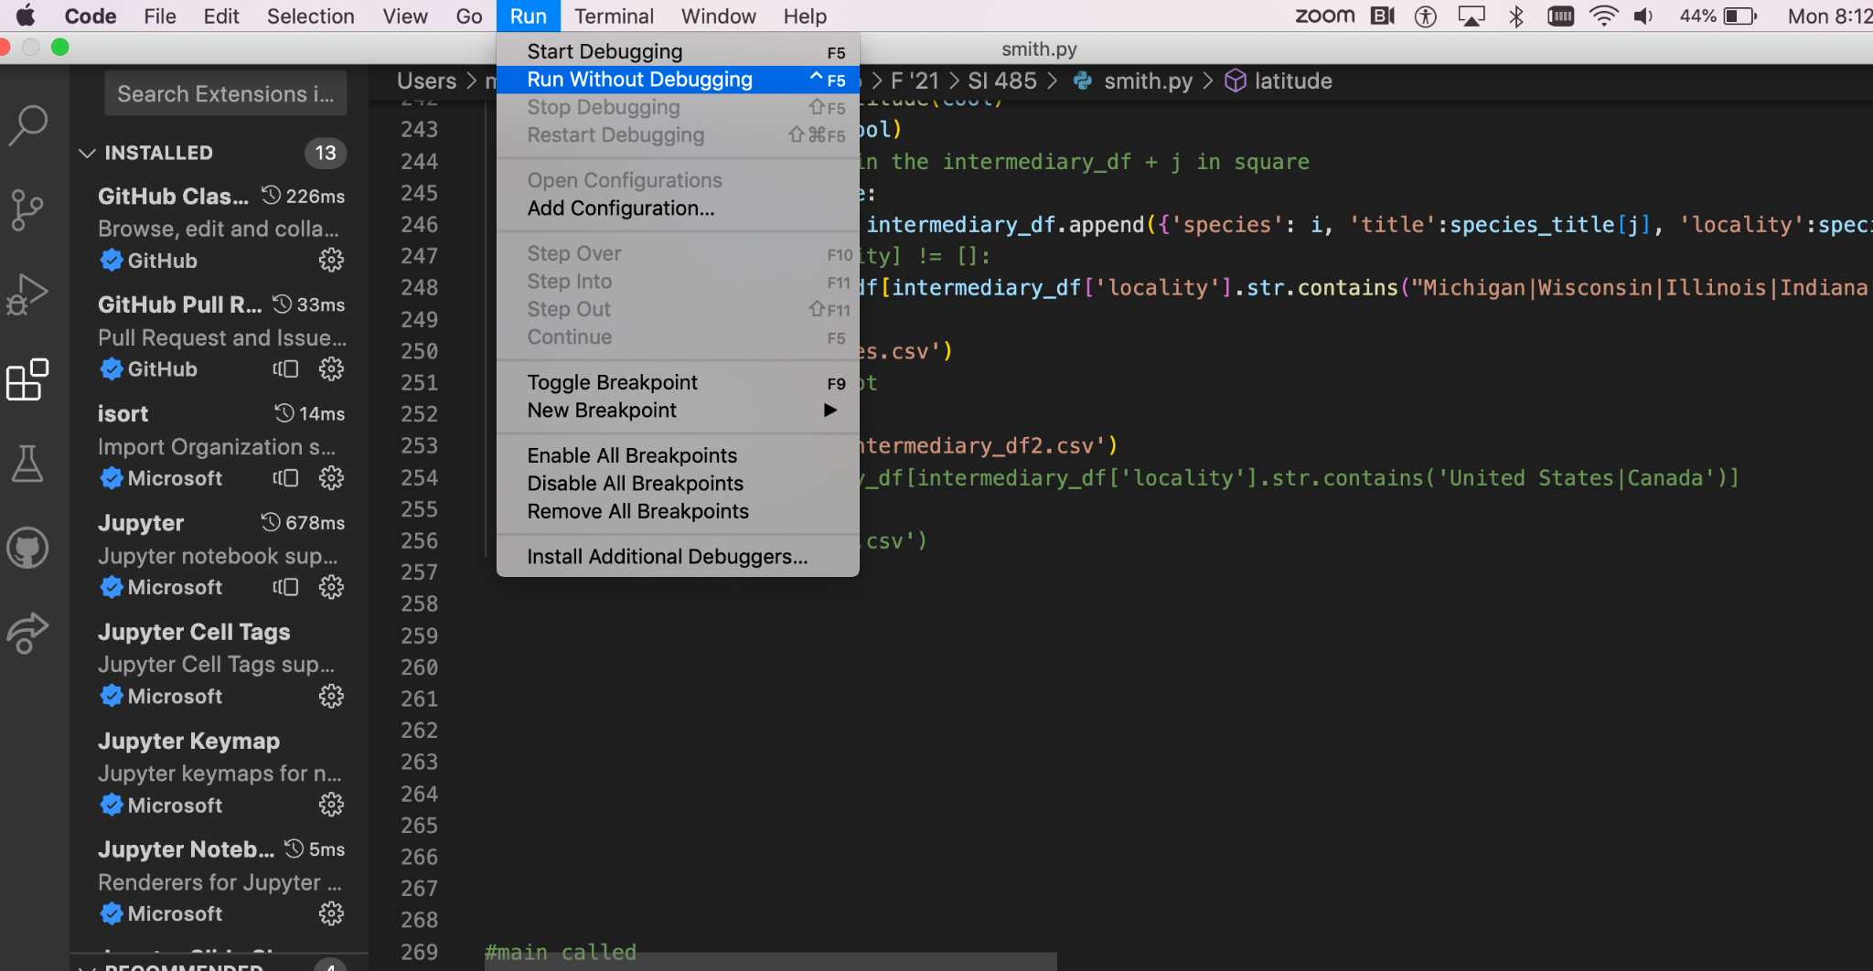

**Editable parts of smith.py**

There are only a few parts of the code we presume you might like to update at a future point. They are the API key and the species to search for.

1. API key
   1. To change the API key–which is the password your computer provides to Smithsonian National Database to unlock their data–request a new API key from Smithsonian National Database: <https://api.data.gov/signup/> Check your email to see your API key. ONLY NEED TO DO THIS ONCE FOR EACH NEW API KEY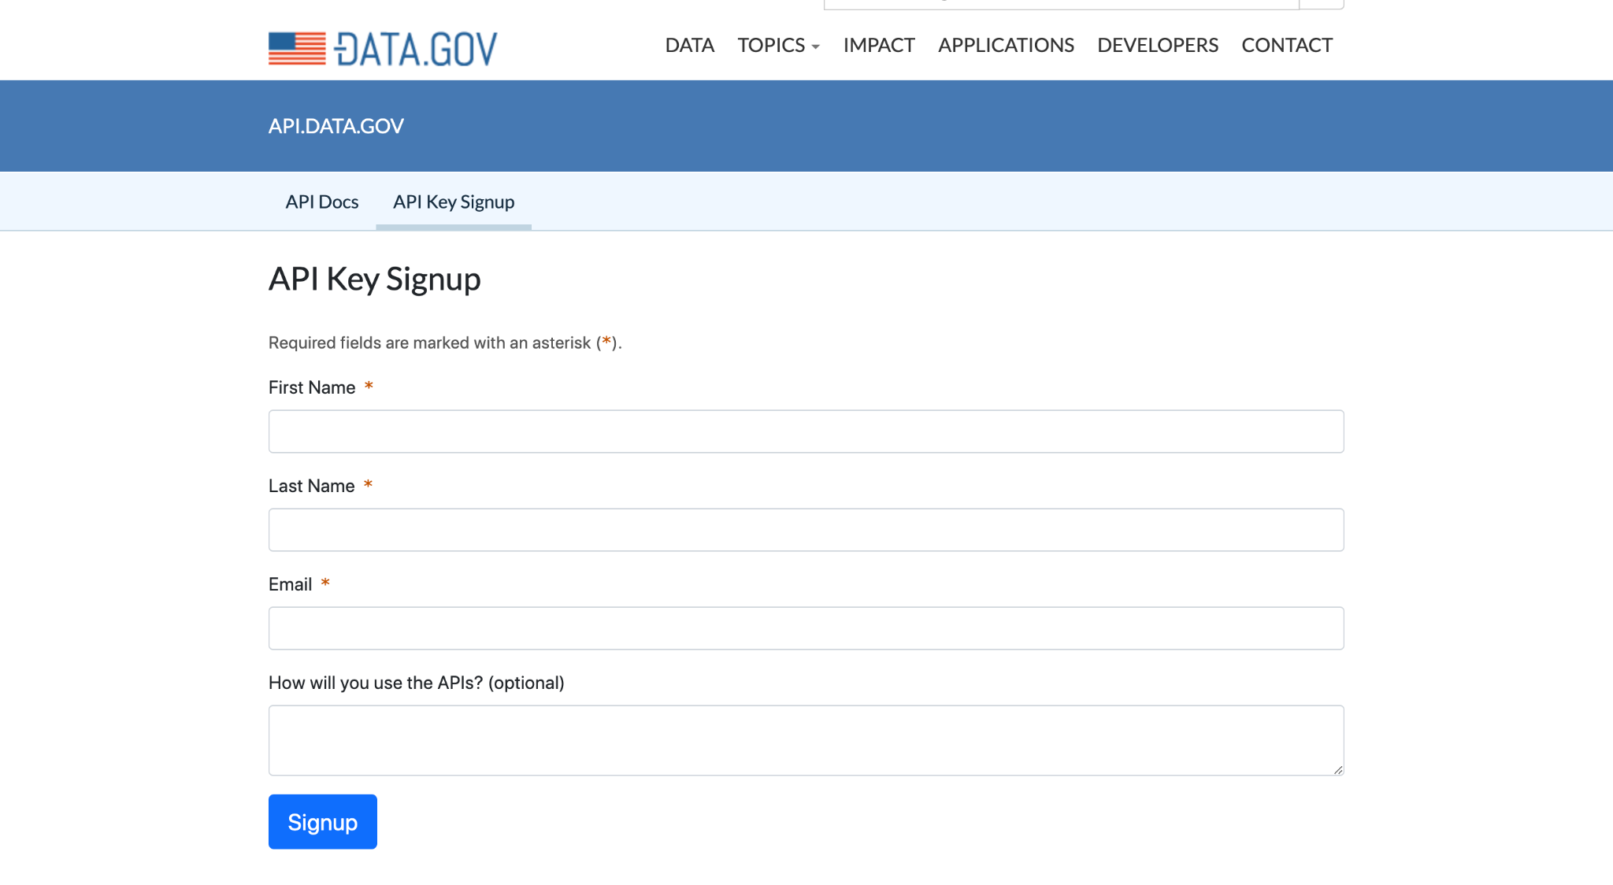
   2. In smith.py, navigate to the section that starts ‘def main():’ a few lines under this code, there is a line that reads: cool = make_a_query(‘########’, i)
   3. Replace the highlighted numbers inside the parentheses after ‘make_a_query’ with your new API key.
2. Species to search for
3. The species list came directly from the ‘Scientific Name’ column in the [GLANSIS Spp. Tracking](https://docs.google.com/spreadsheets/d/1YlxNHJKyJENIovKrvw7UWsK7S_WDacay/edit#gid=1743903809) google sheet. To add more species to search for, either add them to GLANSIS Spp. Tracking or add them to a new google sheet so long as the column with the species is still labeled ‘Scientific Name’ and you specify the correct file, the steps outlined below will work.
4. NEED TO DO OR CODE WON’T RUN: Download [GLANSIS Spp. Tracking](https://docs.google.com/spreadsheets/d/1YlxNHJKyJENIovKrvw7UWsK7S_WDacay/edit#gid=1743903809) (or your new sheet with the exact same formatting) google sheet to your computer.
5. copy the full filepath of the file and paste it into pd.read_csv(“INSERT HERE”). You are replacing my filepath, “Users/madelinetrumbauer/Local Desktop/ F ‘21/SI 485/Tracking.csv” with yours since the file is now on your computer.
6. tracking = pd.read_csv("/Users/madelinetrumbauer/Local Desktop/F '21/SI 485/Tracking.csv")
7. NEED TO DO OR CODE WON’T RUN: Update file path of GLANSIS Specimen Bulk Upload Template.
   1. Download [GLANSIS Specimen Bulk Upload Template](https://docs.google.com/spreadsheets/d/1qiR5PxfLP_m-ZJC3GStRKZeGkZKiSZwu/edit#gid=891200978) google sheet to your computer.
   2. Copy the full filepath of the file you just downloaded and past it into read_csv(). You are replacing my filepath with yours.
8. bulk = pd.read_csv("/Users/madelinetrumbauer/Local Desktop/F '21/SI 485/bulk.csv")

In this project, we assumed the desired columns and the formatting would remain exactly the same as the [GLANSIS Specimen Bulk Upload Template](https://docs.google.com/spreadsheets/d/1qiR5PxfLP_m-ZJC3GStRKZeGkZKiSZwu/edit#gid=891200978). I did not design the code for the formatting of the csv or the fields that it pulls from to be editable. Therefore, all further code should not be edited.